**Interior**

**Will Rose**

I, Will Rose, will be working on the interior of the electric assist recumbent tricycle. This involves the locations of all vehicle operating devices, such as the steering wheel, peddles, and mirrors. Also, additional accessories that could be added to the vehicle (depends on accessory group), such as climate controls, radio, power windows.

The main engineering principle involved in my area will be the ergonomics of the whole system and its adaptability.

Ergonomics is the field study that deals with the relationship between people and their working environment (Canadian Oxford Dictionary). In our case it will be the driver and the vehicle.

How will the ergonomics of our design allow for a comfortable drive by the user? Will they be able to sustain long periods in our vehicle if they have to commute far?

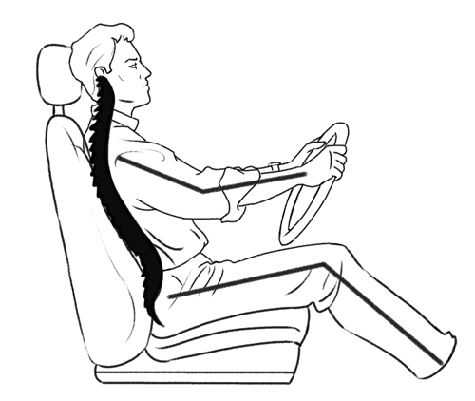

[www.activemotionphysio.ca](http://www.activemotionphysio.ca/article.php?aid=1449)

No one person is ever the same, and so we have to design the vehicle with this in mind. Adaptability is important because it will allow for a wider range of people to use our vehicle. How will the necessary devices be able to move to allow for a custom fit for each person? Which devices will be allowed to move to offer the optimum comfort and ease for the driver?

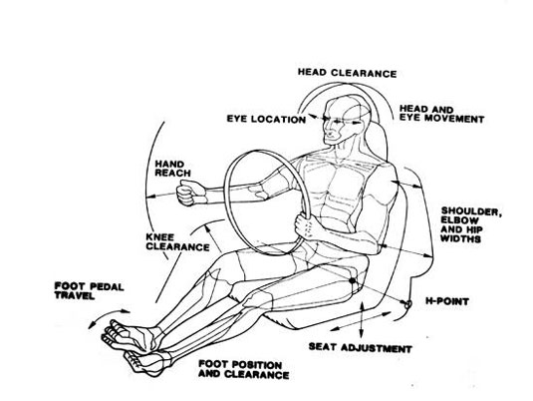

[www.dsource.in](http://www.dsource.in/course/ergonomics/auto-ergo/introduction/introduction.html)

Research Sources:

Mathew P. Reed. (2013). Research: *Driver and Passenger Ergonomics* [Online]. Available: mreed.umtri.umich.edu/mreed/research_ergonomics.html*‎*

American National Standards Institute. (2013)*. Vehicle Ergonomics Standard* [Online]. Available: webstore.ansi.org/ergonomics/vehicle_ergonomics.aspx*‎*

Canadian Centre for Occupational Health and Safety. (2009, June 2). *Driving and Ergonomics* [Online]. *Available:* www.ccohs.ca/oshanswers/ergonomics/driving.html*‎*